
Holy Cross College

Semester 2 Examination 2019
Question/Answer Booklet

Please place your student identification label in this box
Year 10 Earth and Space Science

Student Name
Student’s Teacher

- Time allowed for this paper

Working time for paper: 30 minutes

Materials required/recommended for this paper

- To be provided by the supervisor

This Question/Answer Booklet
Data Sheet

To be provided by the candidate

Standard items: pens, pencils, eraser, correction fluid, ruler, highlighters.
Special items: non-programmable calculators satisfying the conditions set by the School Curriculum and Standards Authority for this course.

Important note to candidates

No other items may be taken into the examination room. It is your responsibility to ensure that you do not have any unauthorised notes or other items of a non-personal nature in the examination room. If you have any unauthorised material with you, hand it to the supervisor before reading any further.

Structure of this paper

Section | Number of questions available | Number of questions to be answered | Suggested working time  (minutes) | Marks available | Percentage of exam
Section One:  Multiple Choice | 10 | 10 | 10 | 10 | 40
Section Two:  Short Answer | 8 | 8 | 20 | 17 | 60
 |  |  |  | 27 | 100

Instructions to candidates

1. The rules for the conduct of examinations at Holy Cross College are detailed in the College Examination Policy. Sitting this examination implies that you agree to abide by these rules.

2. Write your answers in this Question/Answer Booklet.

3. Working or reasoning should be clearly shown when calculating or estimating answers.

4. You must be careful to confine your responses to the specific questions asked and to follow any instructions that are specific to a particular question.

5. Spare pages are included at the end of this booklet. They can be used for planning your
responses and/or as additional space if required to continue an answer.

• Planning: If you use the spare pages for planning, indicate this clearly at the top of the
page.
• Continuing an answer: If you need to use the space to continue an answer, indicate in
the original answer space where the answer is continued, i.e. give the page number.
Fill in the number of the question(s) that you are continuing to answer at the top of the page.

Section I: Multiple choice questions (circle the correct answer)
- Which of the following are correct matches between an Earth system and its main type of contents?
- Hydrosphere – water and ice
- Biosphere – soils and sediments
- Geosphere – oceans
- Atmosphere – air
- The rock cycle operates primarily in which Earth system?
- Atmosphere
- Geosphere
- Hydrosphere
- Biosphere
- Rain falls on a mountainside, seeps into the bedrock and is absorbed by the roots of a pine tree. Apart from the hydrosphere, which Earth systems does the water pass through?
- atmosphere → biosphere → geosphere
- biosphere → geosphere → atmosphere
- atmosphere → geosphere → biosphere
- geosphere → biosphere → atmosphere

- 30% of the Sun's energy that hits the Earth is reflected back into space. The other 70% is:
- partly absorbed by the land and sea surface and partly destroyed by the atmosphere
- absorbed by the land and sea surface only
- absorbed by the atmosphere only
- absorbed by the land, sea and atmosphere
- Which two types of heat transfer do not require the movement of matter?
- Convection
- Evaporation
- Radiation
- Conduction

- Ecosystems involve interactions between which Earth system(s)?
- Biosphere, atmosphere, hydrosphere and geosphere
- Biosphere and atmosphere
- Biosphere only
- Biosphere, atmosphere and hydrosphere

- Which of these statements about greenhouse gases are correct?
- They make up the ozone layer, which protects life from harmful radiation
- They reflect solar radiation back into space
- They make up about 1% of the atmosphere
- They're generally harmful to life on Earth

- Which of the following are greenhouse gases?
- Nitrogen
- Oxygen
- Methane
- Carbon dioxide
- Water vapour

- Which climate zones tend to have high annual rainfall?
- Subtropical
- Temperate
- Polar
- Tropical

- Which of the following are effects of global warming?
- Melting of sea ice, land ice sheets and glaciers
- Crop harvesting occurs earlier in the year than previously
- Sea level rise due to thermal expansion
- Increased use of plastics

Section II: Short answer questions

- Over geological time periods, weathering and erosion can cause an entire mountain range to disappear. Describe how this vast amount of matter is moved around the Earth's surface and how it might eventually become solid rock again. (1 mark)
_______________________________________________________________________________________________________________________________________________________________________________________________________________

- What are the Earth’s four major spheres? (2 marks)
_______________________________________________________________________________________________________________________________________________________________________________________________________________

- Explain how plants and animals influence the composition of the atmosphere through exchanges of matter. (1 mark)
_______________________________________________________________________________________________________________________________________________________________________________________________________________

- Describe a pathway by which carbon moves from the atmosphere through three living things and back into the atmosphere. At each step, explain the process that brings about the carbon transfer. (3 marks)
_______________________________________________________________________________________________________________________________________________________________________________________________________________

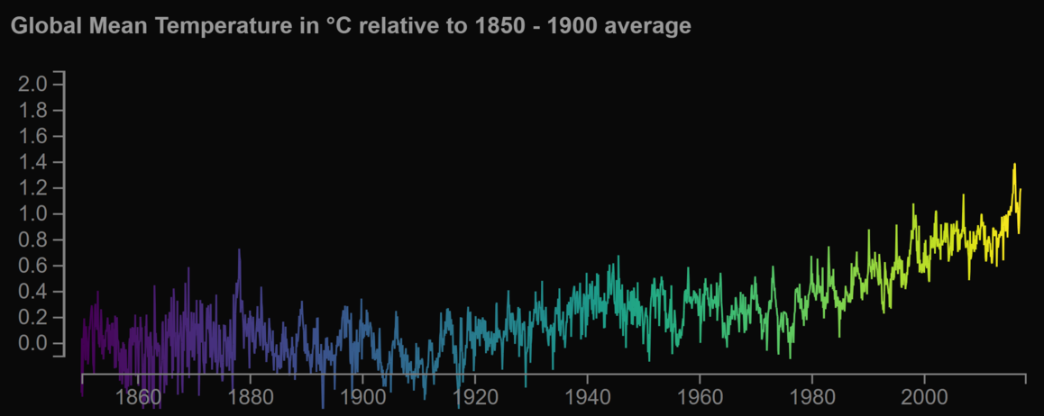
- The above graph shows that global mean temperatures go up and down from one year to the next. For example, 1992 was 0.2°C cooler than the previous year. Use the graph to explain how this is consistent with global warming over the past century. (2 marks)
_______________________________________________________________________________________________________________________________________________________________________________________________________________
- Explain two ways that human activities are impacting the carbon cycle. (2 marks)
_______________________________________________________________________________________________________________________________________________________________________________________________________________
- Give two ways in which humans have contributed to the enhanced greenhouse effect. (2 marks)
_______________________________________________________________________________________________________________________________________________________________________________________________________________

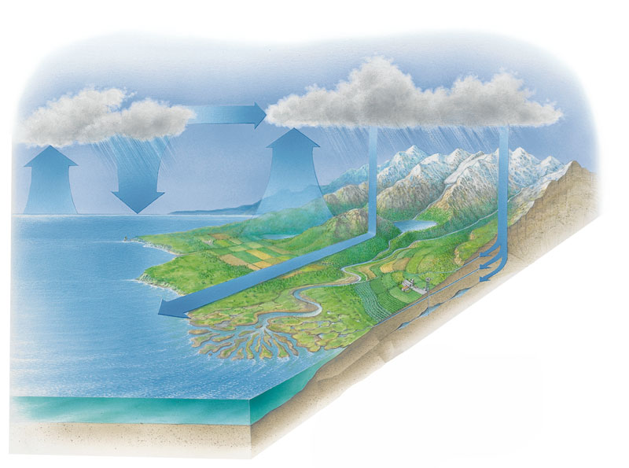
- Using the diagram above, list the main stages of the water cycle. (4 marks)
______________________________________________________________________________________________________________________________________________________________________________________________________________________________________________________________________________________________________________________________________________________________________________________________________________________________

